International Journal of Japan Association
for Management Systems (IJAMS) For Word

Aaaaa AAAA^{a*}, Bbbbb BBª, Ccccc CC^{b}

ªDepartment of Management Systems,Tokyo Keiei University, ******, Tokyo, 111-1111 Japan
^{b}Management Systems Co. Ltd., ******, Osaka, 222-2222 Japan

Abstract
This document is a guideline to producing a camera-ready manuscript to submitted to IJAMS (International Journal of Japan Association for Management Systems), and demonstrates how to set the page-style on the Microsoft Word. We recommend that the manuscript is created based on this file.

Keywords: IJAMS, ijams guideline.doc, Microsoft word

- Introduction
This document introduces how to write your paper using our template files, and provides some useful information to authors of papers. Submission of a manuscript is considered on the understanding that it contains original unpublished work and has not been submitted for publication elsewhere.
Only electronically submitted manuscript is accepted. Send a PDF file by email to IJMS@starfox.is.oit.ac.jp.

- We prepared a sample of word file(this document). Please refer the latest version.
- Manuscript must be in English and should generally not exceed 10 pages. The standard is 6 pages in length, including figures, tables and references.
- Your paper should be submitted as a source file and a PDF file.

- Page Style
- Paper size: A4 format
- Paper formatting: Refer to this guideline format. Double-column, single-spaced, 10pt Times New Roman font.
- If you include figures, the resolutions should be as high as possible.

- Page Layout
  - Heading
Title page should have the following information: (i) the title; (ii) the name(s) and institutional affiliation(s) of the author(s); (iii) an abstract of less than 300 words; (iv) keywords. The complete e-mail address of the corresponding author should be given on the footer of same sheet.

  - For Microsoft Word
- Please use the menu of style for Microsoft Word 2007 or later version.

  - Figures and Tables
Figures should be inserted at the appropriate place in your text. Figures may extend over the two columns, up to 16.5 cm if necessary.
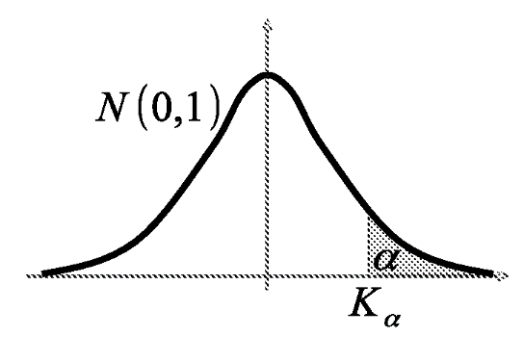
Figure 1 Example of figure

Table 1 Example of table

Line
1 | 2 | 3
1,1 | 1,2 | 1,3
2,1 | 2,2 | 2,3
3,1 | 3,2 | 3,3

Tables should also be inserted at the appropriate point in your text, and they may also extend over the two columns up to 16.5 cm if necessary. An example of a table is shown in Table 1.
Position figures and tables near the first reference of the figure or table in the text. Please avoid long captions in figures and tables.

  - Mathematical Formulas
Plesae describe the Mathematical fomulas refer to following example.We don't recommend using Microsoft Equation 3.0. Please use the new Equation editor for Word 2010 or later.
$$S=\sum_{k}^{n-1}{\sum_{j=k+1}^{n}{sgn(x_{j}-x_{k}) }}$$ | (1)

$$sgn\left(θ\right)=\left\{\begin{matrix}1 & θ>0 \\ 0 & θ=0 \\ -1 & θ<0\end{matrix}\right.$$
However, it is recommended that you do not number an equation if it will not be cited in your paper.
Further formulae referred to in the paper should be displayed on a separate line and numbered consecutively throughout such as (1) or (1.1) on the right.

  - Balance of Last Page
In order to balance the columns on the last page, Section delimiter must be given somewhere within the the last page.

  - References
References should appear in the text as numbers in brackets, such as [1] or [1,2] and be listed at the end of the article according to the sequence they appear in the text. Reference labels should be unique.
Journal names should be written in full. For a paper in a contributed volume see [1] a journal paper [2]; and a book [3]:

- Page charge and Copy right
Page charge must be paid by authors for the publication of their papers. The page charges is 15,000 yen.
Copyright: The Japan Association for Management Systems holds the copyright for all materials that it publishes.

Acknowledgments
Acknowledgments are placed in a separate section at the end of the paper, before the References. You can use an unnumbered section.

References(Sample)
[1] S. Fujishige: Linear and nonlinear optimization problems with submodular constraints. In M. Iri and K. Tanabe (eds.): Mathematical Programming . Recent Development and Applications (KTK Scientific Publishers, Tokyo, 1989), 203-225.
[2] H. Ishii and Y. L. Lee: Stochastic Facility Construction Problem. International Journal of Japan Associations for Management Systems, 1 (2009), 3-9.
[3] H. Takagi: Queueing Analysis: A Foundation of Performance Evaluation, Vol. 1: Vacation and Priority Systems, Part 1 (North-Holland, Amsterdam, 1991).

